**How to use RAK2247 on your X86 Linux PC**

In order to use RAK2247 as a concentrator module and turn your x86 machine into a LoRaWAN Gateway you need the following:

RAK2247 LoRa Gateway Concentrator Module

mPCIe to USB board

1. Insert the RAK2247 mPCIe board into the USB carrier board and into a free USB port (refer to the Figure below). Your Linux should pick it up as an USB device.

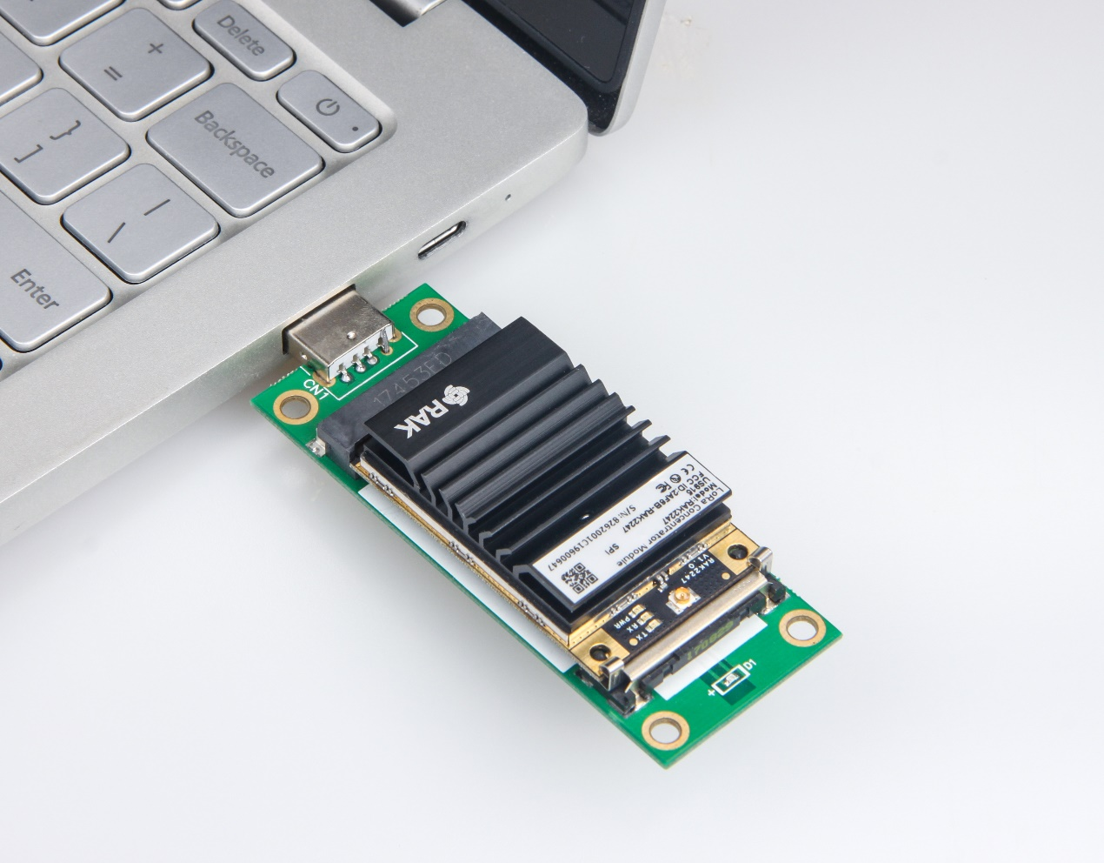

**Figure 1 |** RAK2247 with the mPCIe board

1. Open a command line and enter the command below in order to clone the Github repository that is required for the process to be completed:

git clone https://github.com/RAKWireless/rak_common_for_gateway.git

1. Get the name of the interface you are using to connect to the internet by using the command:

ifconfig

In the example in Figure 2 this is the name of the wireless interface “wlx6045bdf0cf64”.

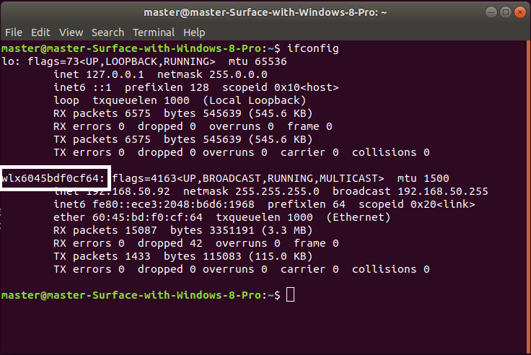

**Figure 2 |** Network interface name

cd rak_common_for_gateway/lora/rak2247

1. You need to insert the nae you got in the previous step for your interface in the following files:

rak_common_for_gateway/lora/rak2247/install.sh

rak_common_for_gateway/lora/set_eui.sh

rak_common_for_gateway/lora/update_gwid.sh

You need to replace the following line:

GATEWAY_EUI_NIC=”eth0”

With the line

GATEWAY_EUI_NIC=”wlx6045bdf0cf64h0”

Again, the values are just an example. Remember to do this for all 3 files in step 4.

1. Add the following lines of code to the end of the install.sh file (in addition to the inserting the name of the interface from the previous step)

cp ../set_dui.sh packet_forwarder/lora_pkt_fwd/

cp ../update_gwid.sh packet_forwarder/lora_pkt_fwd/

cp ../start.sh packet_forwarder/lora_pkt_fwd/

mkdir -p /opt/ttn-gateway/

cp -rf packet_forwarder/opt/ttn-gateway/

Note: If you want the packet forwarder to start on boot, you need to also add the lines below:

cp ../ttn-gateway.service/lib/systemd/system/

systemctl enable ttn-gateway.service

1. Save the “install.sh” file and execute it in order to install:

sudo ./install.sh

1. Wait for the installation to complete.

Using the commands below go and run the newly created process (lora_pkt_fwd):

cd /opt/ttn-gateway/packet_forwarder/lora_pkt_fwd

sudo ./lora_pkt_fwd

Note: If you added the additional lines in step 5 it will execute every time on boot.

1. The regional parameter configuration for all the supported regions are located in the folder </opt/packet_forwarder/lora_pkt_fwd/global_conf>. In case you need to adjust the region frequency band for example, do so before running the process (EU868 is the default).
2. You should now see your Gateway in TTN.